Map: United States 1850 (p. 326 and A5) Name ______________________________________________ Per. _______

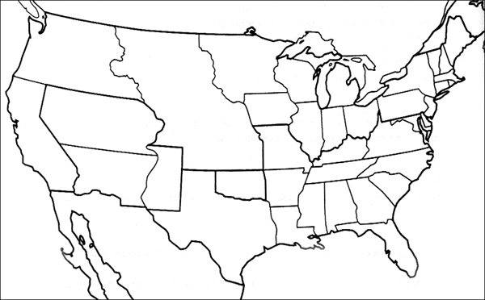

1. Draw a dot and label each city: 2. Use a different color to outline each section: 4. Label the mountain ranges:
Independence U.S. States U.S. Territory Appalachian Mountains Los Angeles Mexico British Territory Rocky Mountains Sierra Nevada
New Orleans 5. Draw in a blue line and label each river:
Sacramento 3. Draw in each trail with a different color. Colorado River Ohio River Salt Lake City California Trail Mormon Trail Columbia River Snake River
San Antonio Oregon Trail Santa Fe Trail Missouri River Rio Grande
San Francisco Old Spanish Trail Mississippi River Platte River

